TERRAFORM TASK3

Creating variables pick the name from the given variable code

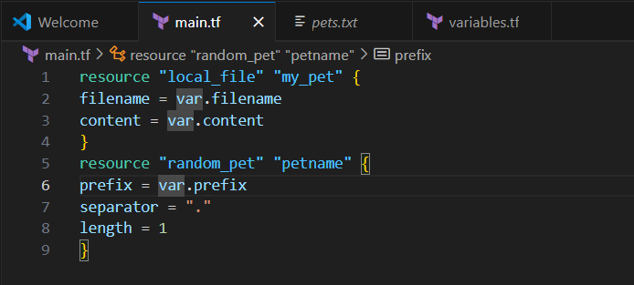

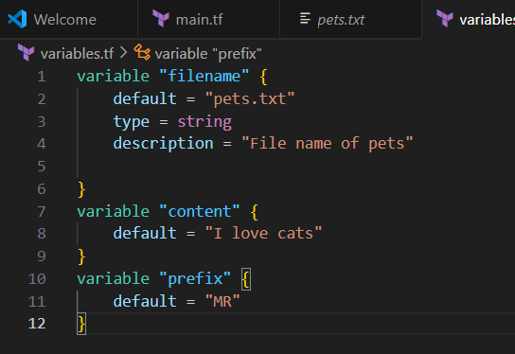

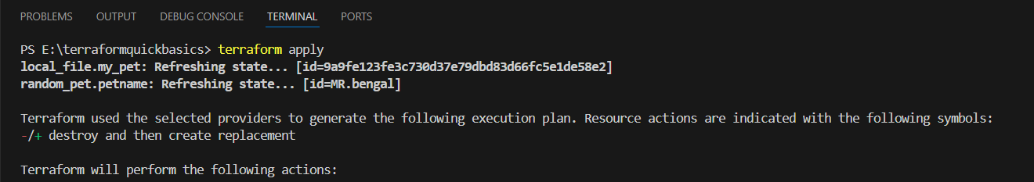

Replaces with wild.txt in variables and ctrlS

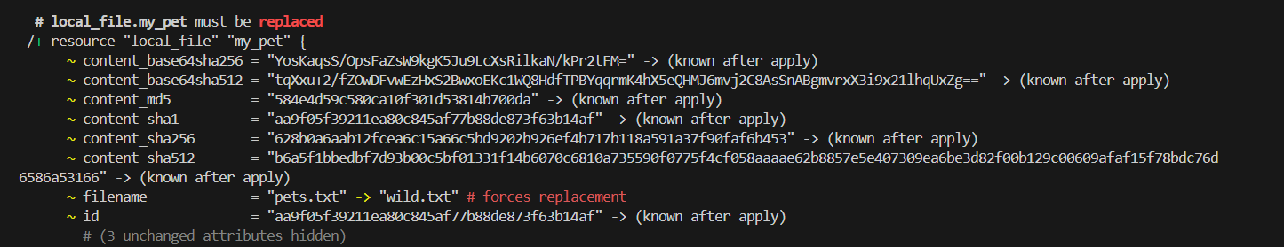

Command line flags. Changing or removing the content from variables.tf code. It is asking the values in terminal.

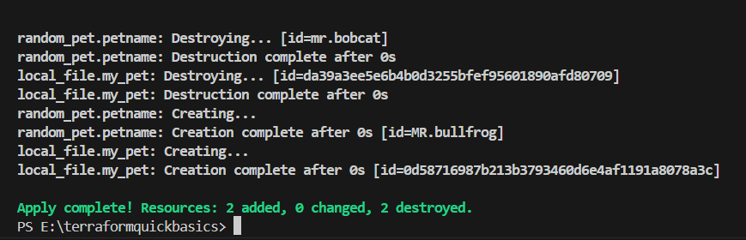

Here, we have destroyed the files

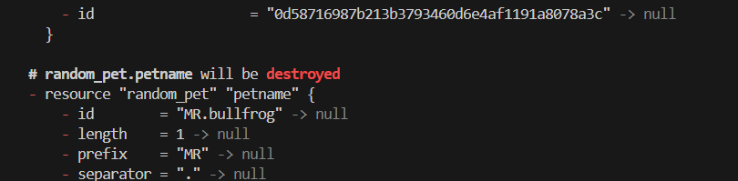

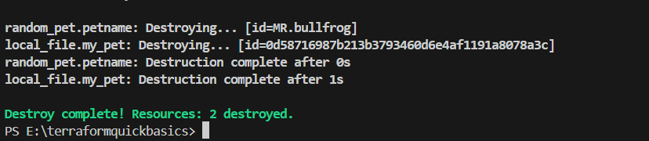

PS E:\terraformquickbasics> Set-Item -Path env:TF_VAR_filename -Value 'wild.txt'

PS E:\terraformquickbasics> Set-Item -Path env:TF_VAR_content -Value 'i love dogs'

PS E:\terraformquickbasics> Set-Item -Path env:TF_VAR_prefix -Value 'miss'

PS E:\terraformquickbasics> terraform apply

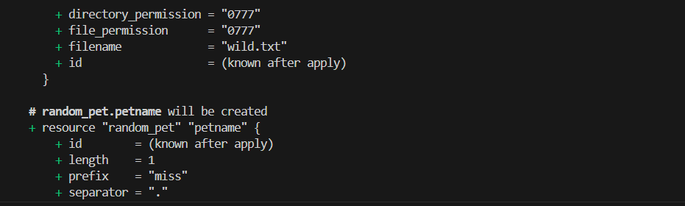

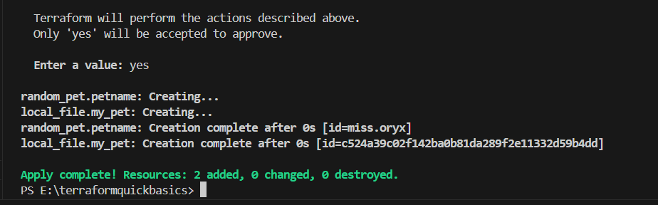

CLF text was created

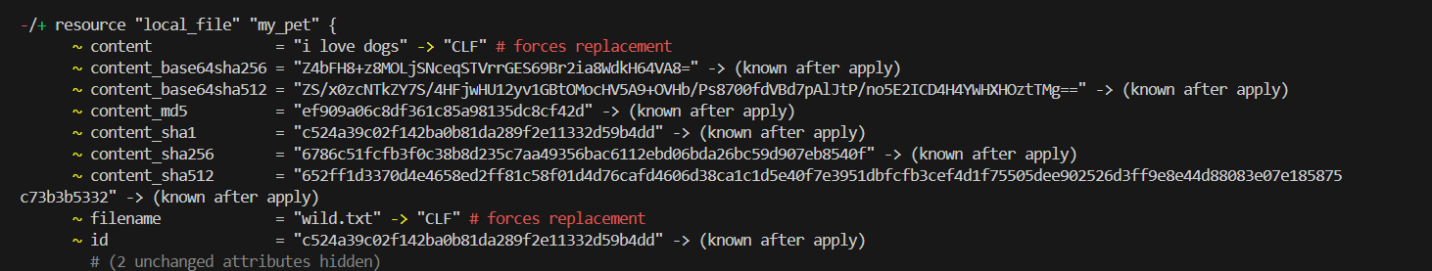

Create one Jenkins job using MAVEN PROJECT for the below code with two stages.

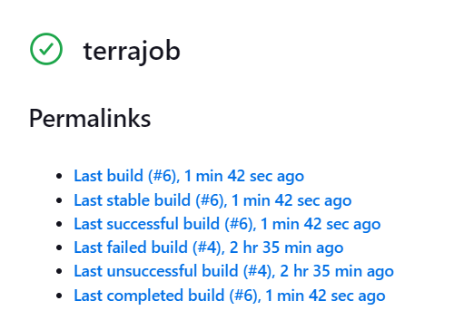

stage 1: Git clone

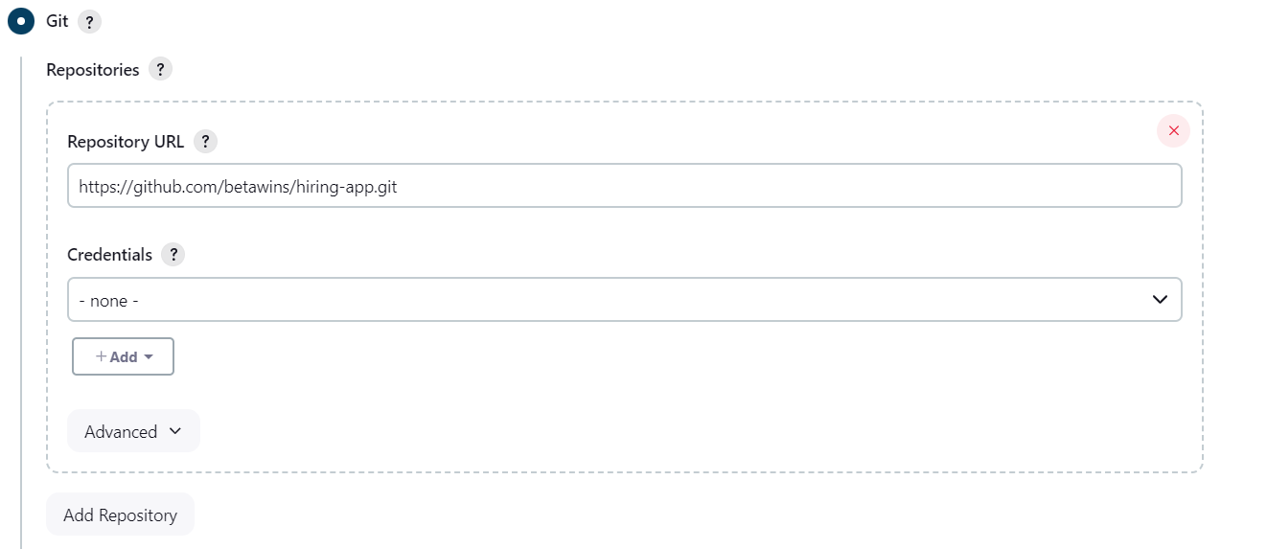

stage 2: Maven compilation

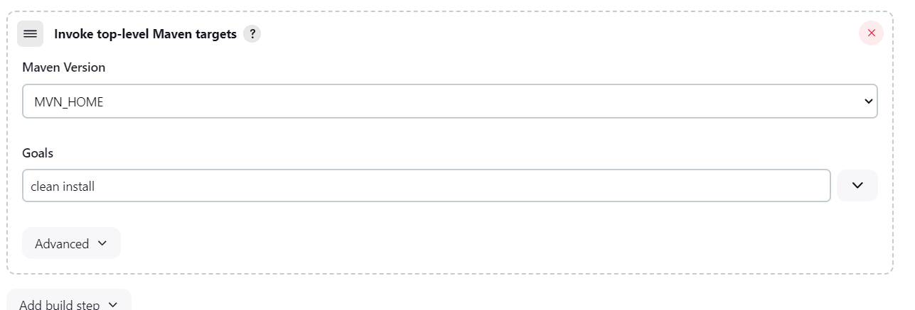

It is the output of job with GIT & maven compilation

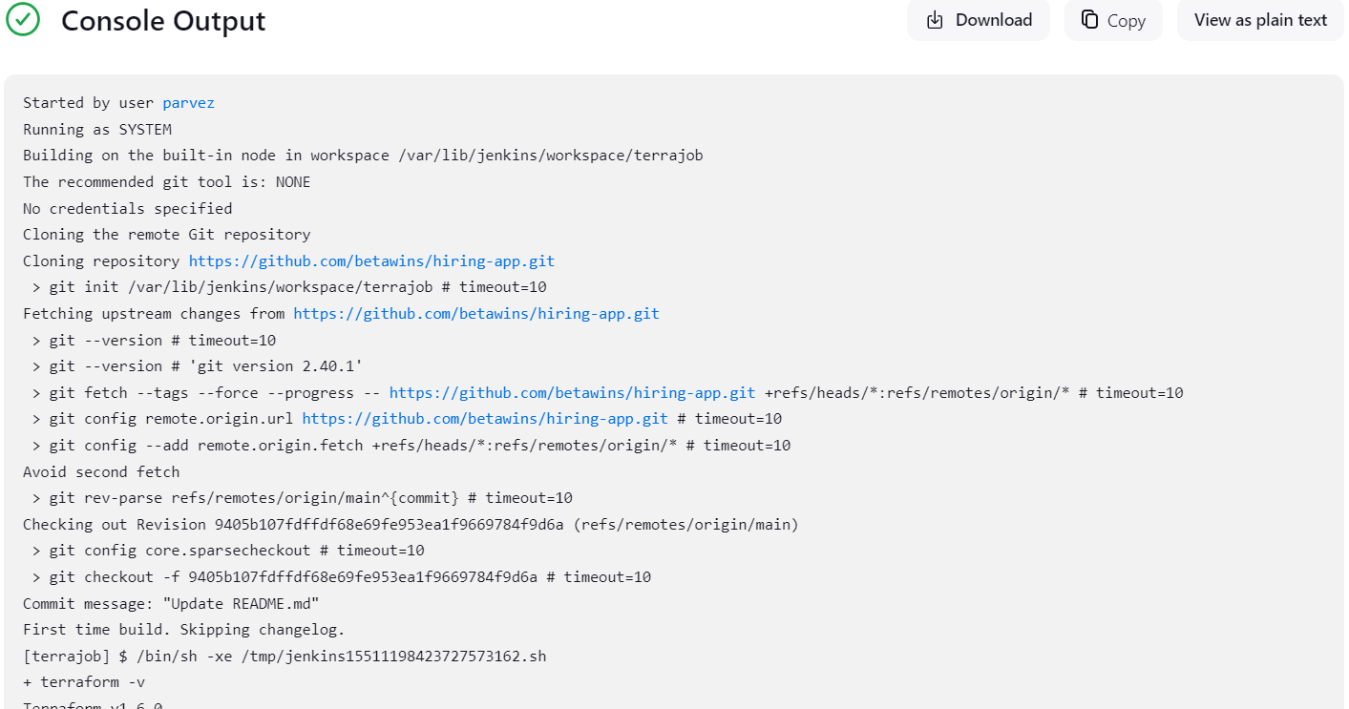

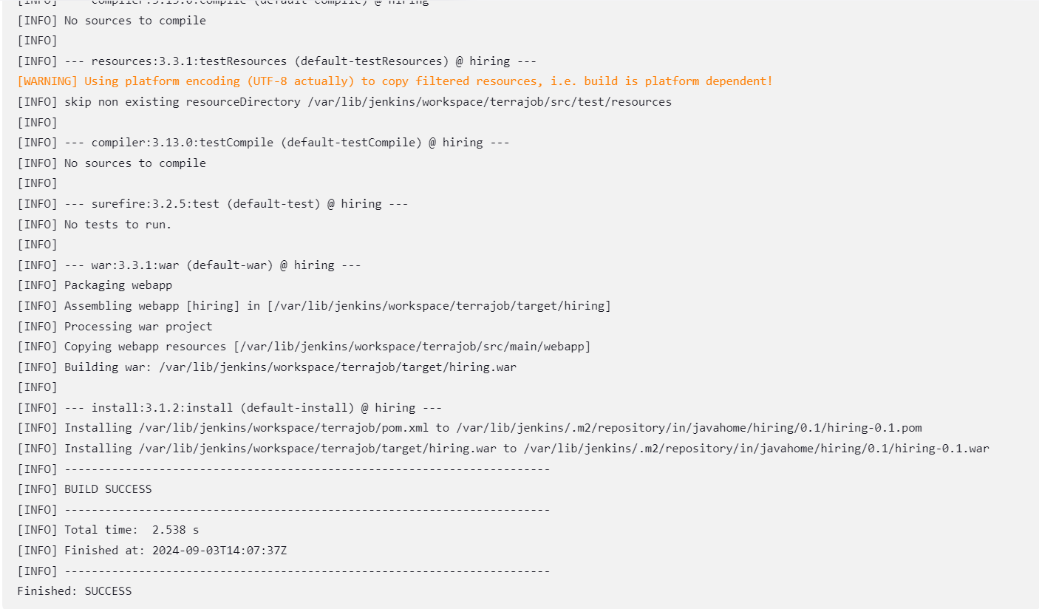

Created a job terra_job

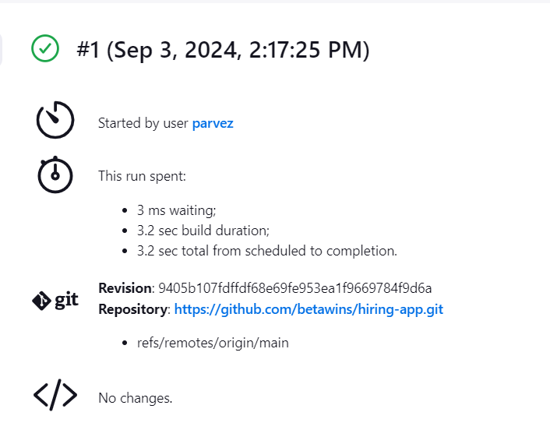

Maven compilation





Use the below code and create a parameterized job in Jenkins

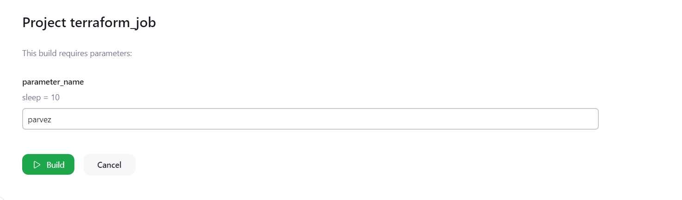

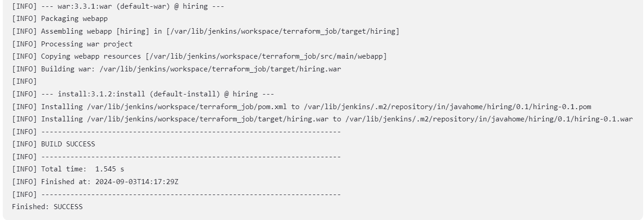

What are the global variables in Jenkins?

1)In Jenkins, global variables are predefined variables that are available to all pipelines without any explicit declaration.

2)These variables provide access to Jenkins features, environment variables, and pipeline stages.

3)They help simplify pipeline scripts and allow for reusable configurations.